Setup minikube at your local and explore creating namespaces (Go through official documentation).

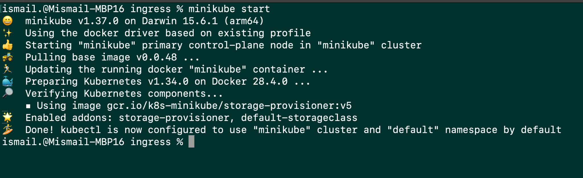

Kubectl get namespace

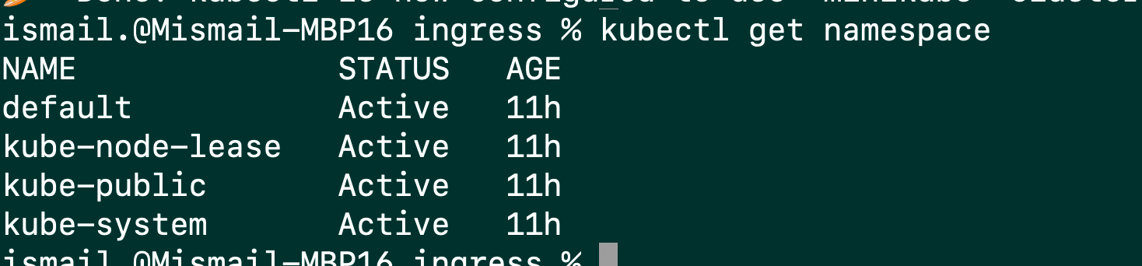

setting up namespace for a request



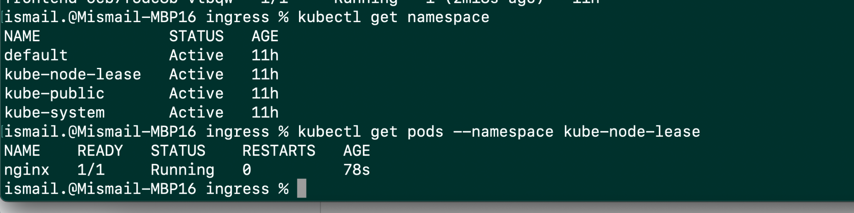

### Setting the namespace preference

